REGRESSION QUALIFICATION

To perform a multiple linear regression, the dataset needs to meet the following assumptions:

1. Linearity: The relationship between the independent variables and the dependent variable should be linear.

2. Independence: The observations should be independent of each other.

3. Homoscedasticity: The variance of the residuals should be constant across all levels of the independent variables.

4. Normality: The residuals should be approximately normally distributed.

5. Multicollinearity: There should be little to no multicollinearity among the independent variables.

LINEARITY

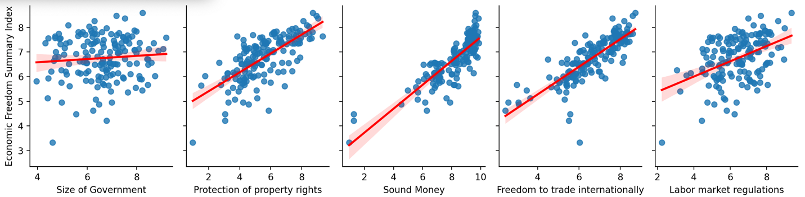

NORMALITY

HOMOSCEDASTICITY

The Variance Inflation Factors (VIFs) for dependant variables are all below 5, which indicates that multicollinearity is not an issue in your model. The VIFs for each variable are:

* + Size of Government: 1.127542
  + Protection of property rights: 1.775957
  + Sound Money: 1.867878
  + Freedom to trade internationally: 1.732333
  + Labor market regulations: 1.166030

The Durbin-Watson test statistic is 1.9572291364683867, which is close to 2. This suggests that there is no significant autocorrelation in the residuals, and the assumption of independence of errors is satisfied.